Module 4 – Introduction to DBMS
Introduction to SQL
Theory Questions:
- What is SQL, and why is it essential in database management?
SQL (Structured Query Language) is a standard programming language used to interact with databases. It allows you to create, read, update, and delete data stored in a database.

🔹 Why SQL is essential in Database Management
- Data Retrieval
  - SQL helps you quickly fetch data using queries like SELECT.
- Data Manipulation
  - You can insert, update, or delete data using commands like INSERT, UPDATE, and DELETE.
- Database Structure Management
  - SQL is used to create and modify database structures (tables, schemas) using CREATE, ALTER, and DROP.
- Data Security
  - It allows setting permissions and controlling access to data using commands like GRANT and REVOKE.
- Efficient Data Handling
  - SQL can handle large volumes of data efficiently and perform complex operations like filtering, sorting, and joining tables.
- Standard Language
  - SQL is widely used across different database systems like MySQL, Oracle, SQL Server, etc., making it a universal language for databases.

- Explain the difference between DBMS and RDBMS.
Feature | DBMS | RDBMS
Full Form | Database Management System | Relational Database Management System
Data Storage | Stores data in files | Stores data in tables
Relationship | No relationship between data | Data is related using keys
Structure | Simple structure | More organized structure
Data Redundancy | Higher | Lower
Examples | File system, XML | MySQL, Oracle, SQL Server
3. Describe the role of SQL in managing relational databases.
Role of SQL in Managing Relational Databases (Simple):
- Create tables: SQL is used to create database tables (CREATE)
- Store data: Insert data into tables (INSERT)
- Retrieve data: Get data using queries (SELECT)
- Update data: Modify existing data (UPDATE)
- Delete data: Remove data (DELETE)
- Manage relationships: Use keys and joins to connect tables
4. What are the key features of SQL?
Key Features of SQL (Simple):
- Easy to use: Simple and readable language
- Data Querying: Retrieve data using SELECT
- Data Manipulation: Insert, update, delete data (INSERT, UPDATE, DELETE)
- Data Definition: Create and modify tables (CREATE, ALTER, DROP)
- Security: Control access using GRANT and REVOKE
- Data Control: Manage transactions using COMMIT and ROLLBACK
LAB EXERCISES: • Lab 1: Create a new database named school_db and a table called students with the following columns: student_id, student_name, age, class, and address.
CREATE DATABASE school_db;
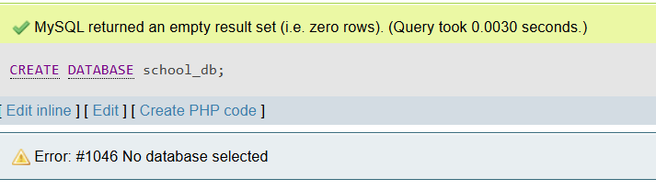
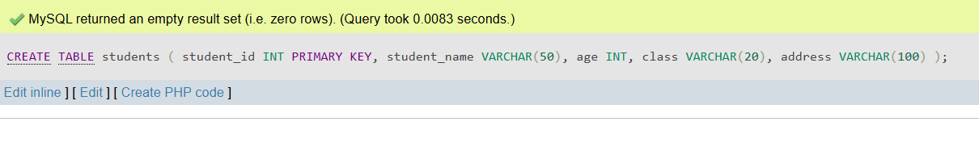

CREATE TABLE students (
student_id INT PRIMARY KEY,
student_name VARCHAR(50),
age INT,
class VARCHAR(20),
address VARCHAR(100)
);

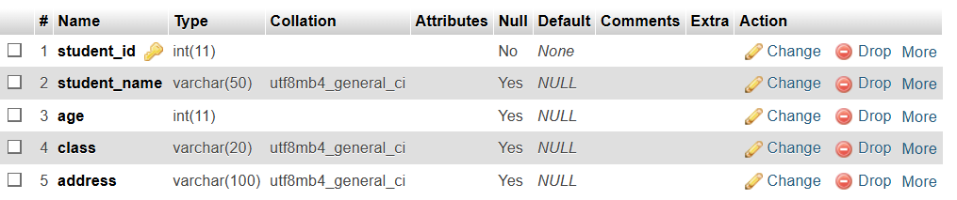
Lab 2: Insert five records into the students table and retrieve all records using the SELECT statement.
INSERT INTO students VALUES
(1, 'Raj', 18, '12th', 'Surat'),
(2, 'Amit', 17, '11th', 'Ahmedabad'),
(3, 'Neha', 16, '10th', 'Mumbai'),
(4, 'Priya', 15, '9th', 'Delhi'),
(5, 'Rohan', 18, '12th', 'Pune');
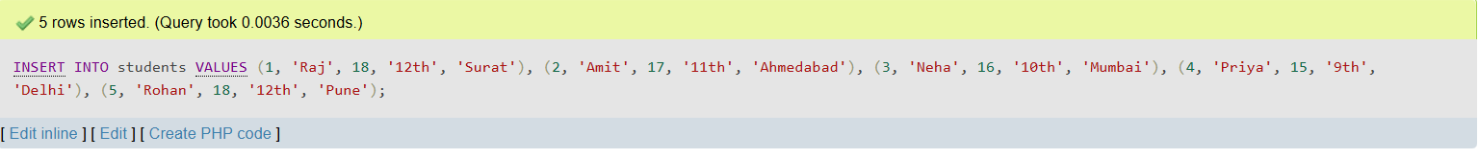
SELECT * FROM students;
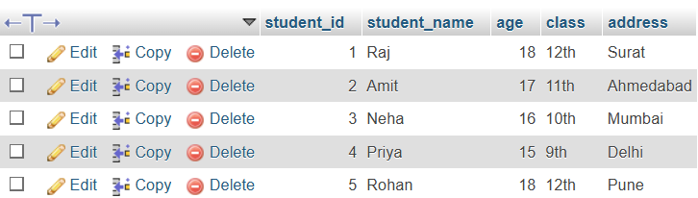

2. SQL Syntax
Theory Questions:
1. What are the basic components of SQL syntax?
Basic Components of SQL Syntax (Simple):
- Keywords: Special words like SELECT, INSERT, UPDATE, DELETE
- Table Name: The name of the table you are working with
- Columns: The fields (data) you want to access
- Conditions: Use WHERE to filter data
- Operators: Symbols like =, >, <, AND, OR
2. Write the general structure of an SQL SELECT statement.
SELECT column1, column2
FROM table_name
WHERE condition
GROUP BY column_name
HAVING condition
ORDER BY column_name;
3. Explain the role of clauses in SQL statements.
Role of Clauses in SQL Statements (Simple):
Clauses are parts of an SQL query that define what data to select and how to display it.
👉 Main roles:
- SELECT: chooses the columns
- FROM: specifies the table
- WHERE: filters the data (condition)
- GROUP BY: groups data
- HAVING: filters grouped data
- ORDER BY: sorts the result
LAB EXERCISES:
• Lab 1: Write SQL queries to retrieve specific columns (student_name and age) from the students table.
SELECT student_name, age FROM students;
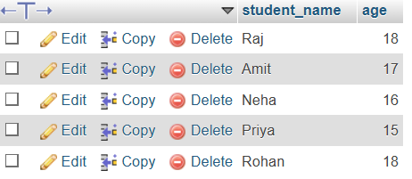
• Lab 2: Write SQL queries to retrieve all students whose age is greater than 10.
SELECT * FROM students WHERE age > 10;
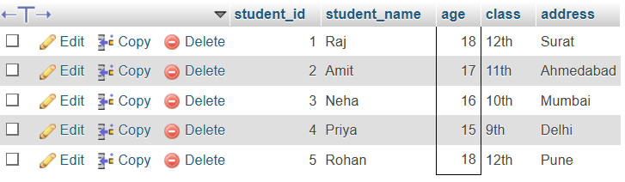
- SQL Constraints
Theory Questions:
1. What are constraints in SQL? List and explain the different types of constraints.
Constraints in SQL (Simple):
Constraints are rules applied to table columns to ensure the data is accurate and valid.

🔹 Types of Constraints:
- NOT NULL
→ Ensures a column cannot have empty (NULL) values
- UNIQUE
→ Ensures all values in a column are different
- PRIMARY KEY
→ Uniquely identifies each record (combines NOT NULL + UNIQUE)
- FOREIGN KEY
→ Links one table to another (maintains relationship)
- CHECK
→ Ensures values meet a specific condition (e.g., age > 18)
- DEFAULT
→ Sets a default value if no value is given
2. How do PRIMARY KEY and FOREIGN KEY constraints differ?

Feature | PRIMARY KEY | FOREIGN KEY
Purpose | Uniquely identifies each record | Links one table to another
Uniqueness | Must be unique | Can have duplicate values
NULL Values | Not allowed | Can allow NULL
Table | Exists in the same table | Refers to another table
Number | Only one primary key per table | Can have multiple foreign keys

3. What is the role of NOT NULL and UNIQUE constraints?
Role of NOT NULL and UNIQUE Constraints (Simple):
- NOT NULL
→ Ensures that a column cannot have empty (NULL) values
→ Every record must have a value in that column
- UNIQUE
→ Ensures that all values in a column are different (no duplicates)
LAB EXERCISES:
• Lab 1:
Create a table teachers with the following columns: teacher_id (Primary Key), teacher_name (NOT NULL), subject (NOT NULL), and email (UNIQUE).
CREATE TABLE teachers (
teacher_id INT PRIMARY KEY,
teacher_name VARCHAR(50) NOT NULL,
subject VARCHAR(50) NOT NULL,
email VARCHAR(100) UNIQUE
);
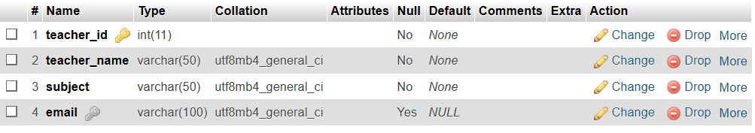
• Lab 2: Implement a FOREIGN KEY constraint to relate the teacher_id from the teachers table with the students table.
ALTER TABLE students
ADD teacher_id INT,
ADD CONSTRAINT fk_teacher
FOREIGN KEY (teacher_id)
REFERENCES teachers(teacher_id);
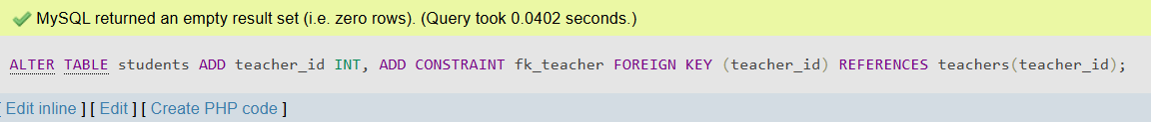

- Main SQL Commands and Sub-commands (DDL)
Theory Questions:

1. Define the SQL Data Definition Language (DDL).
SQL Data Definition Language (DDL) (Simple):
DDL is a part of SQL used to define and manage the structure of a database.
👉 It is used to:
- Create tables
- Modify tables
- Delete tables
👉 Common DDL commands:
- CREATE
- ALTER
- DROP
- TRUNCATE
2. Explain the CREATE command and its syntax.
CREATE Command in SQL (Simple):
The CREATE command is used to create a new database or table.

🔹 Syntax (for creating a table):
CREATE TABLE table_name (
column1 datatype,
column2 datatype,
column3 datatype
);

🔹 Example:
CREATE TABLE student (
id INT,
name VARCHAR(50),
age INT
);

3. What is the purpose of specifying data types and constraints during table creation?
Purpose of Data Types and Constraints (Simple):
- Data Types
→ Define what kind of data a column can store (like INT, VARCHAR)
→ Help store data in the correct format
- Constraints
→ Set rules on data (like NOT NULL, UNIQUE)
→ Ensure data is accurate and valid
LAB EXERCISES:
• Lab 1: Create a table courses with columns: course_id, course_name, and course_credits. Set the course_id as the primary key.
CREATE TABLE courses (
course_id INT PRIMARY KEY,
course_name VARCHAR(50),
course_credits INT
);
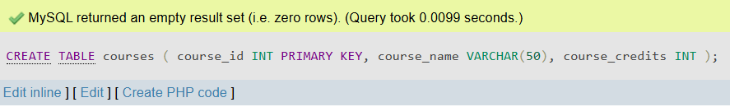
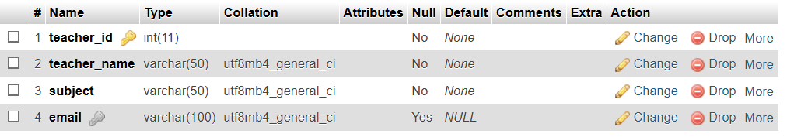
• Lab 2: Use the CREATE command to create a database university_db.
CREATE DATABASE university_db;
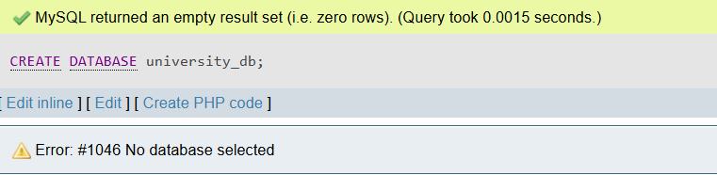

- ALTER Command
Theory Questions:

1. What is the use of the ALTER command in SQL?
ALTER Command in SQL (Simple):
The ALTER command is used to modify an existing table structure.
👉 It can be used to:
- Add new columns
- Delete columns
- Change data types
- Rename columns
2. How can you add, modify, and drop columns from a table using ALTER?
Using ALTER to Add, Modify, and Drop Columns (Simple):

🔹 Add a Column
ALTER TABLE table_name
ADD column_name datatype;

🔹 Modify a Column
ALTER TABLE table_name
MODIFY column_name new_datatype;

🔹 Drop a Column
ALTER TABLE table_name
DROP COLUMN column_name;

LAB EXERCISES:
• Lab 1: Modify the courses table by adding a column course_duration using the ALTER command.
ALTER TABLE courses
ADD course_duration INT;
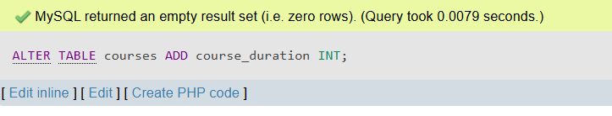
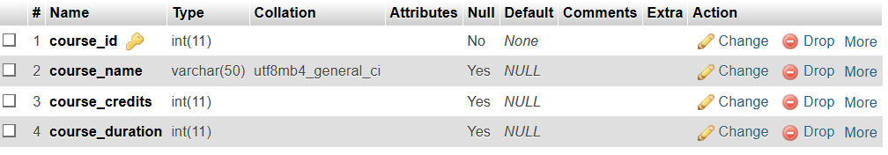
• Lab 2: Drop the course_credits column from the courses table.
ALTER TABLE courses
DROP COLUMN course_credits;
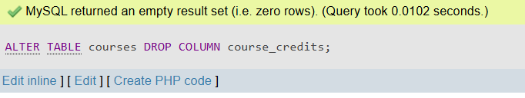
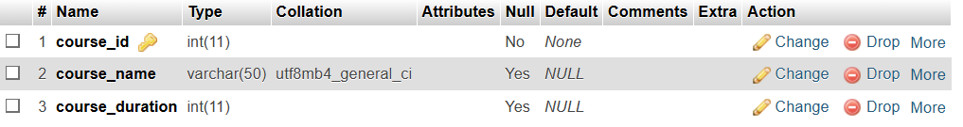
- DROP Command
Theory Questions:
1. What is the function of the DROP command in SQL?
DROP Command in SQL (Simple):
The DROP command is used to delete a table or database completely.
👉 It removes:
- Table structure
- All data inside the table

🔹 Example:
DROP TABLE table_name;

2. What are the implications of dropping a table from a database?
Implications of Dropping a Table (Simple):
- All data is deleted
→ Every record in the table is permanently removed
- Table structure is removed
→ Columns, constraints, and indexes are deleted
- Cannot be recovered easily
→ Data is lost unless you have a backup
- Affects related tables
→ If linked with foreign keys, it may cause errors or break relationships
LAB EXERCISES:
• Lab 1: Drop the teachers table from the school_db database.
Lab 2: Drop the students table from the school_db database and verify that the table has been removed.
DROP TABLE school_db.students;
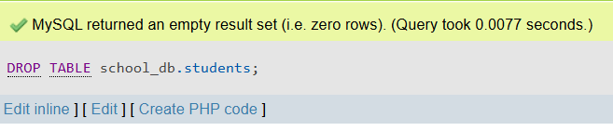
USE school_db;
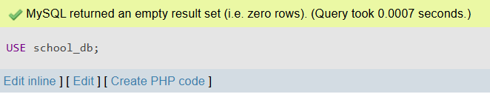
SHOW TABLES;
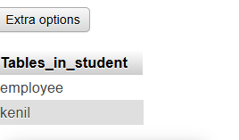

- Data Manipulation Language (DML)
Theory Questions:
1. Define the INSERT, UPDATE, and DELETE commands in SQL
INSERT, UPDATE, and DELETE in SQL (Simple):
- INSERT
→ Used to add new data into a table
- UPDATE
→ Used to change existing data in a table
- DELETE
→ Used to remove data from a table
2. What is the importance of the WHERE clause in UPDATE and DELETE operations?
Importance of WHERE Clause in UPDATE and DELETE (Simple):
- The WHERE clause is used to specify which records to update or delete
👉 Why it is important:
- It prevents updating or deleting all records
- It targets specific rows only
- Helps avoid data loss or mistakes

🔹 Example:
UPDATE student
SET age = 20
WHERE id = 1;

LAB EXERCISES:

• Lab 1: Insert three records into the courses table using the INSERT command.

INSERT INTO courses (course_id, course_name, course_duration)
VALUES
(1, 'Computer Science', 36),
(2, 'Mechanical Engineering', 48),
(3, 'Mathematics', 24);

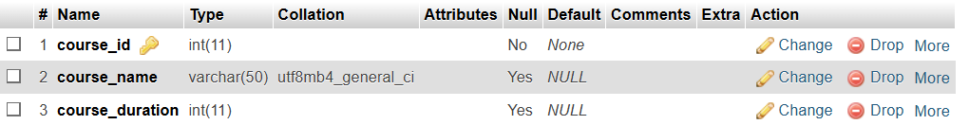

• Lab 2: Update the course duration of a specific course using the UPDATE command
UPDATE courses
SET course_duration = 30
WHERE course_id = 1;
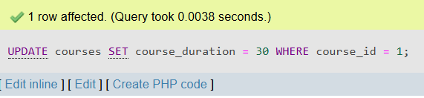
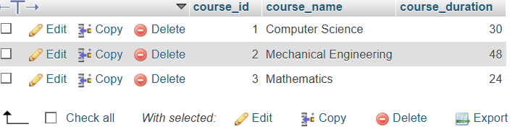
Lab 3: Delete a course with a specific course_id from the courses table using the DELETE command.
DELETE FROM courses
WHERE course_id = 2;
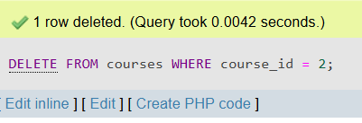
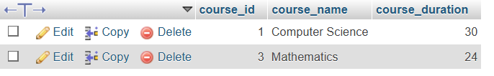
- Data Query Language (DQL)
Theory Questions:
1. What is the SELECT statement, and how is it used to query data?
SELECT Statement in SQL (Simple):
The SELECT statement is used to retrieve (get) data from a database.
👉 How it is used:
- You choose the columns you want
- You specify the table
- You can use conditions with WHERE

🔹 Example:
SELECT name, age
FROM student
WHERE age > 18;

2. Explain the use of the ORDER BY and WHERE clauses in SQL queries.
Use of ORDER BY and WHERE in SQL (Simple):
- WHERE clause
→ Used to filter data based on a condition
→ Example: show only records where age > 18
- ORDER BY clause
→ Used to sort data in ascending (ASC) or descending (DESC) order

🔹 Example:
SELECT *
FROM student
WHERE age > 18
ORDER BY age DESC;

LAB EXERCISES:
• Lab 1: Retrieve all courses from the courses table using the SELECT statement.
SELECT * FROM courses;
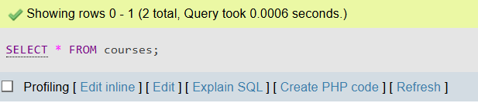
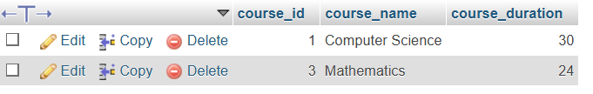
Lab 2: Sort the courses based on course_duration in descending order using ORDER BY.
SELECT * FROM courses
ORDER BY course_duration DESC;
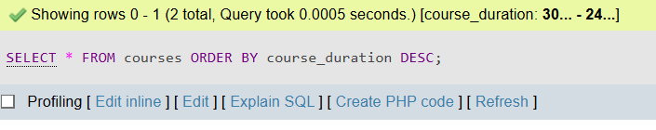
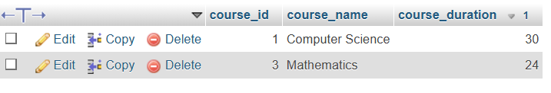
Lab 3: Limit the results of the SELECT query to show only the top two courses using LIMIT.
SELECT * FROM courses
LIMIT 2;
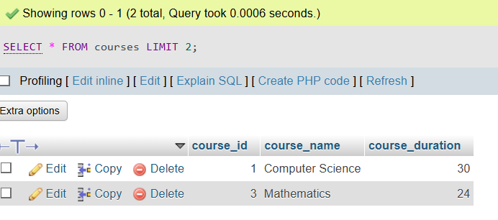
- Data Control Language (DCL)
Theory Questions:
1. What is the purpose of GRANT and REVOKE in SQL?
Purpose of GRANT and REVOKE in SQL (Simple):
- GRANT
→ Used to give permissions to users
→ Example: allow a user to SELECT or INSERT data
- REVOKE
→ Used to remove permissions from users
2. How do you manage privileges using these commands?
Managing Privileges using GRANT and REVOKE (Simple):
- Using GRANT
→ Give specific permissions to a user
GRANT SELECT, INSERT ON table_name TO user_name;
- Using REVOKE
→ Remove permissions from a user
REVOKE INSERT ON table_name FROM user_name;
👉 You can control permissions like:
- SELECT (read data)
- INSERT (add data)
- UPDATE (modify data)
- DELETE (remove data)
LAB EXERCISES:
• Lab 1: Create two new users user1 and user2 and grant user1 permission to SELECT from the courses table.
CREATE USER 'user1'@'localhost' IDENTIFIED BY 'password1';
CREATE USER 'user2'@'localhost' IDENTIFIED BY 'password2';
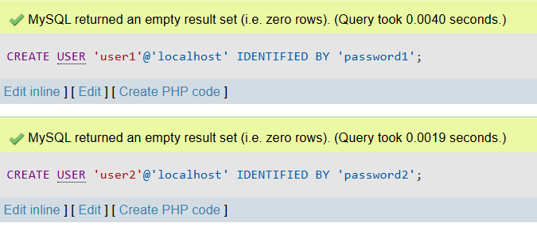
GRANT SELECT ON courses TO 'user1'@'localhost';
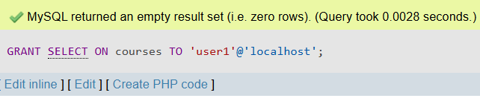
FLUSH PRIVILEGES;

Lab 2: Revoke the INSERT permission from user1 and give it to user2.

Step 1: Revoke INSERT permission from user1
REVOKE INSERT ON courses FROM 'user1'@'localhost';

- Transaction Control Language (TCL)
Theory Questions:
1. What is the purpose of the COMMIT and ROLLBACK commands in SQL?
Purpose of COMMIT and ROLLBACK in SQL (Simple):
- COMMIT
→ Saves all changes made in the database permanently
- ROLLBACK
→ Undoes changes and returns the database to the previous state
2. Explain how transactions are managed in SQL databases.
ransactions in SQL (Simple):
A transaction is a group of SQL operations treated as one unit.
👉 How transactions are managed:
- BEGIN / START TRANSACTION → starts the transaction
- COMMIT → saves all changes permanently
- ROLLBACK → cancels changes if something goes wrong
👉 Why it is important:
- Ensures data is correct and consistent
- Prevents partial updates (all or nothing)
LAB EXERCISES:
• Lab 1: Insert a few rows into the courses table and use COMMIT to save the changes.

Step 1: Start a transaction (optional but recommended)
START TRANSACTION;
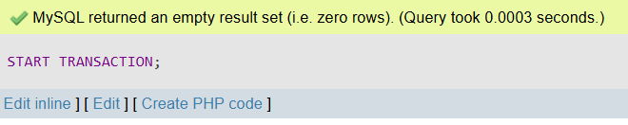

Step 2: Insert rows into the courses table
INSERT INTO courses (course_id, course_name, course_duration)
VALUES
(4, 'Physics', 36),
(5, 'Chemistry', 30);
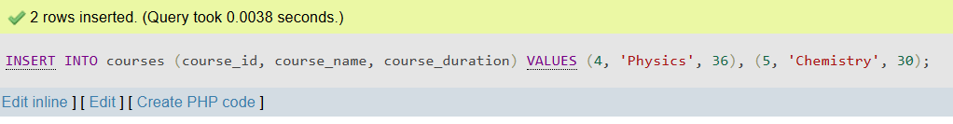
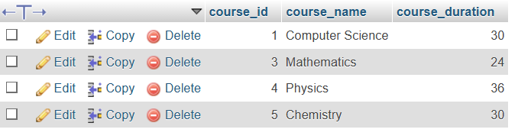

Step 3: Commit the changes
COMMIT;
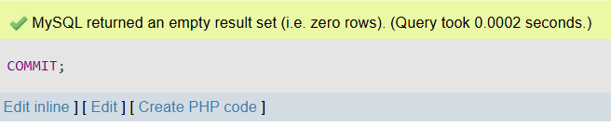

Lab 2: Insert additional rows, then use ROLLBACK to undo the last insert operation.

Step 1: Start a transaction
START TRANSACTION;

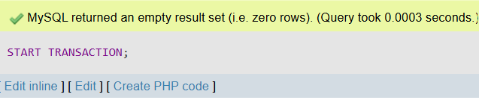

Step 2: Insert additional rows
INSERT INTO courses (course_id, course_name, course_duration)
VALUES
(6, 'Biology', 24),
(7, 'English', 18);

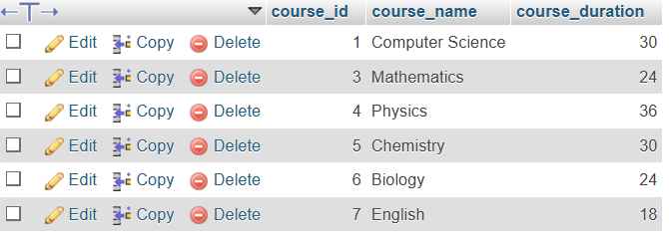

Step 3: Rollback the changes
ROLLBACK;

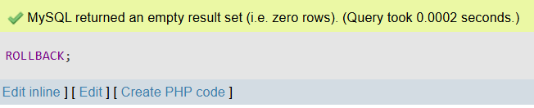

Lab 3: Create a SAVEPOINT before updating the courses table, and use it to roll back specific changes.

Step 1: Start a transaction
START TRANSACTION;
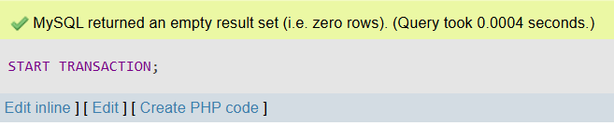

Step 2: Create a SAVEPOINT
SAVEPOINT before_update;

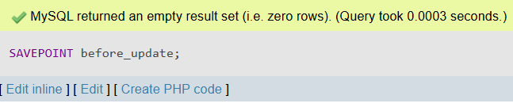

Step 3: Update the courses table
UPDATE courses
SET course_duration = 40
WHERE course_id = 1;

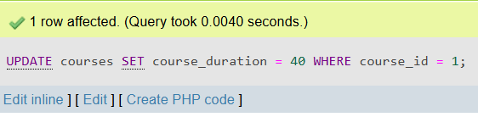

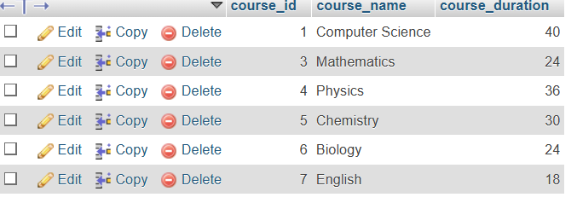

Step 4: Rollback to SAVEPOINT
ROLLBACK TO before_update;
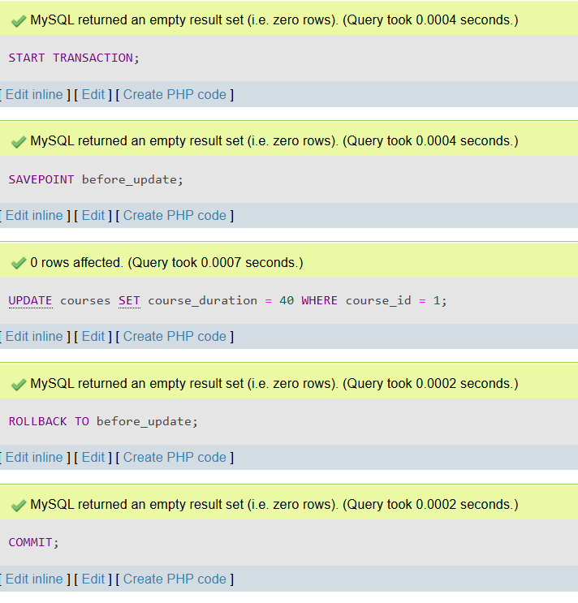

Step 5: Commit the final state

COMMIT;

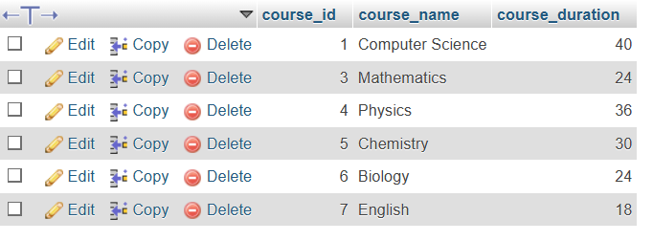

- SQL Joins
Theory Questions:
1. Explain the concept of JOIN in SQL. What is the difference between INNER JOIN, LEFT JOIN, RIGHT JOIN, and FULL OUTER JOIN?
JOIN in SQL (Simple):
A JOIN is used to combine data from two or more tables based on a related column.

🔹 Types of JOIN:
JOIN Type | Description
INNER JOIN | Returns only matching records from both tables
LEFT JOIN | Returns all records from left table and matching from right
RIGHT JOIN | Returns all records from right table and matching from left
FULL OUTER JOIN | Returns all records from both tables (matched + unmatched)

2. How are joins used to combine data from multiple tables?
How JOINs Combine Data from Multiple Tables (Simple):
JOINs are used to link tables using a common column (like id).
👉 How it works:
- You select data from two tables
- Use a JOIN condition (usually with ON)
- Match rows where values are equal

🔹 Example:
SELECT student.name, courses.course_name
FROM student
JOIN courses
ON student.cid = courses.cid;
👉 This will combine data where student.cid = courses.cid
LAB EXERCISES:
• Lab 1: Create two tables: departments and employees. Perform an INNER JOIN to display employees along with their respective departments.

Step 1: Create departments table
CREATE TABLE departments (
dept_id INT PRIMARY KEY,
dept_name VARCHAR(50)
);
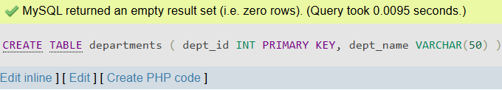
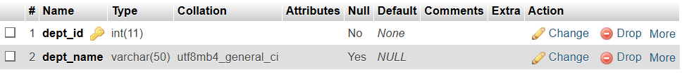

Step 2: Create employees table
CREATE TABLE employees (
emp_id INT PRIMARY KEY,
emp_name VARCHAR(50),
dept_id INT,
FOREIGN KEY (dept_id) REFERENCES departments(dept_id)
);
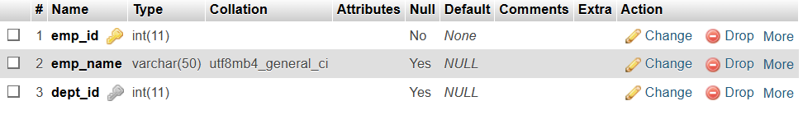

Step 3: Insert sample data
INSERT INTO departments VALUES
(1, 'HR'),
(2, 'IT'),
(3, 'Finance');
INSERT INTO employees VALUES
(101, 'Raj', 2),
(102, 'Amit', 1),
(103, 'Neha', 3);

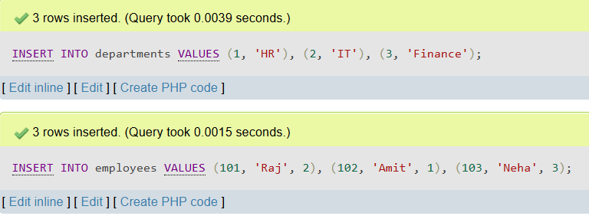

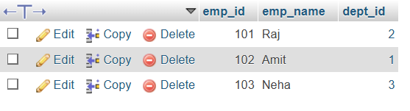

Step 4: Perform INNER JOIN
SELECT employees.emp_id, employees.emp_name, departments.dept_name
FROM employees
INNER JOIN departments
ON employees.dept_id = departments.dept_id;

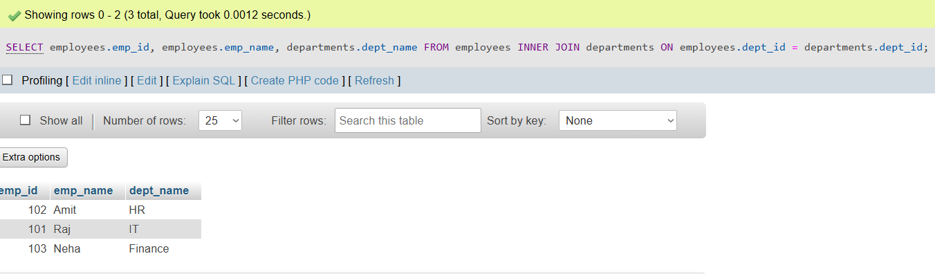

Lab 2: Use a LEFT JOIN to show all departments, even those without employees.

SELECT departments.dept_id, departments.dept_name, employees.emp_name
FROM departments
LEFT JOIN employees
ON departments.dept_id = employees.dept_id;

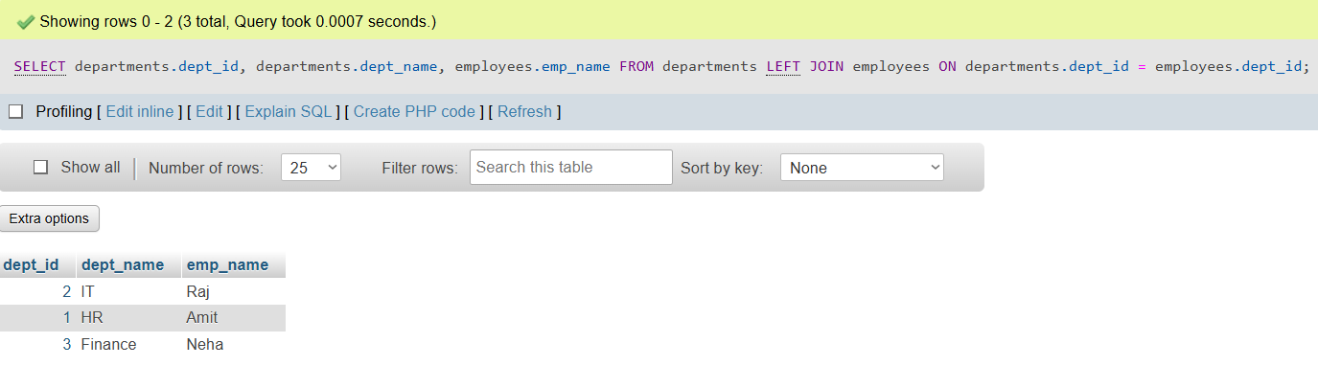

- SQL Group By
Theory Questions:
1. What is the GROUP BY clause in SQL? How is it used with aggregate functions?
GROUP BY in SQL (Simple):
The GROUP BY clause is used to group rows that have the same values in a column.
👉 It is commonly used with aggregate functions like:
- COUNT() → count records
- SUM() → total values
- AVG() → average
- MAX() / MIN() → highest / lowest

🔹 Example:
SELECT cid, COUNT(*)
FROM student
GROUP BY cid;
👉 This groups students by cid and counts them.
2. Explain the difference between GROUP BY and ORDER BY.
Difference between GROUP BY and ORDER BY (Simple):
Feature | GROUP BY | ORDER BY
Purpose | Groups rows with same values | Sorts the result
Use | Used with aggregate functions | Used to arrange data
Result | Reduces rows into groups | Keeps all rows, just changes order
Example | GROUP BY cid | ORDER BY name ASC

LAB EXERCISES:
• Lab 1: Group employees by department and count the number of employees in each department using GROUP BY.
SELECT dept_id, COUNT(*) AS total_employees
FROM employees
GROUP BY dept_id;
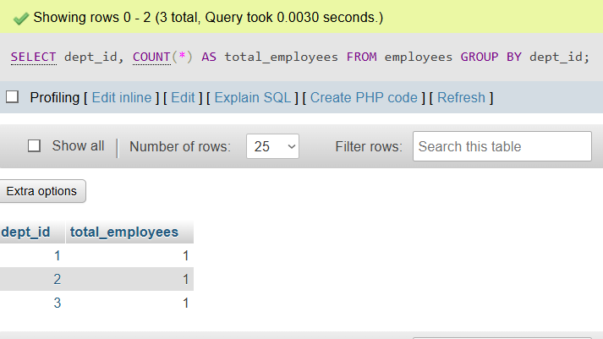
Lab 2: Use the AVG aggregate function to find the average salary of employees in each department.
DESC employees;
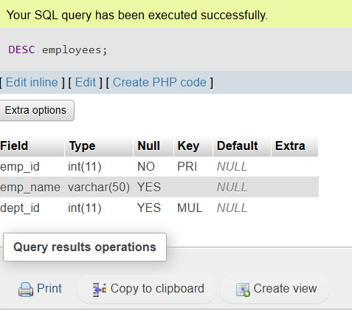
ALTER TABLE employees
ADD salary INT;
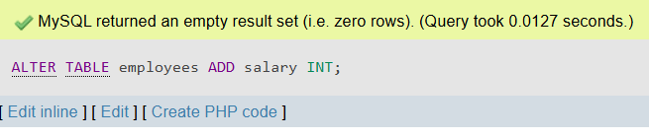
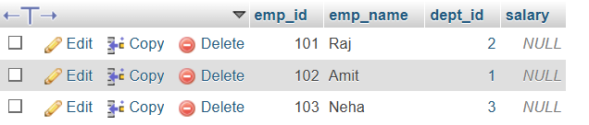
SELECT dept_id, AVG(salary) AS avg_salary
FROM employees
GROUP BY dept_id;
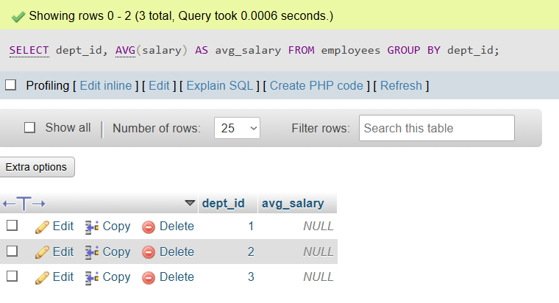

- SQL Stored Procedure
Theory Questions:
1. What is a stored procedure in SQL, and how does it differ from a standard SQL query?
Stored Procedure in SQL (Simple):
A stored procedure is a pre-written set of SQL statements stored in the database that can be executed whenever needed.

🔹 Difference from a Normal SQL Query:
Feature | Stored Procedure | Standard SQL Query
Definition | Saved in database | Written and executed each time
Reusability | Can be reused many times | Not reusable (written again)
Performance | Faster (precompiled) | Slower (runs each time)
Complexity | Can handle complex logic | Usually simple queries

2. Explain the advantages of using stored procedures.
Advantages of Stored Procedures (Simple):
- Reusable
→ Write once and use many times
- Faster Performance
→ Precompiled, so execution is quicker
- Security
→ Users can access procedures without direct access to tables
- Less Code
→ Reduces repeated SQL code
- Handles Complex Logic
→ Can include conditions, loops, and multiple queries
LAB EXERCISES:
• Lab 1: Write a stored procedure to retrieve all employees from the employees table based on department.

Step 1: Create the Stored Procedure
DELIMITER //
CREATE PROCEDURE GetEmployeesByDept(IN deptId INT)
BEGIN
SELECT *
FROM employees
WHERE dept_id = deptId;
END //
DELIMITER ;
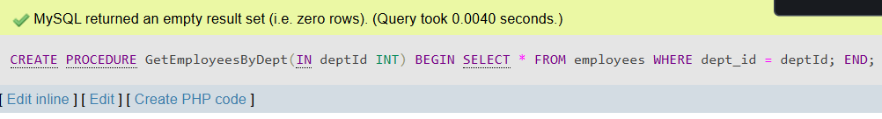

Step 2: Call the Stored Procedure
CALL GetEmployeesByDept(2);
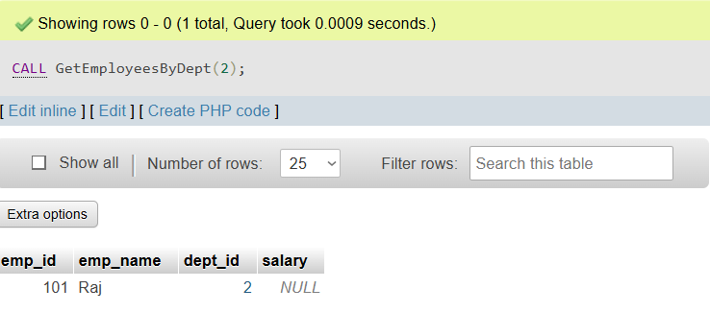
- SQL View
Theory Questions:
1. What is a view in SQL, and how is it different from a table?
View in SQL (Simple):
A view is a virtual table created from a SQL query. It shows data from one or more tables but does not store data itself.

🔹 Difference between View and Table:
Feature | View | Table
Data Storage | Does not store data | Stores actual data
Type | Virtual table | Real table
Creation | Based on a query | Created directly
Space | Does not take much space | Takes storage space
Usage | Used for security and simplicity | Used to store data

2. Explain the advantages of using views in SQL databases.
Advantages of Views in SQL (Simple):
- Security
→ Show only selected data to users
- Simplicity
→ Complex queries can be saved as a simple view
- Data Abstraction
→ Hide complex table structure
- Reusability
→ Use the same query multiple times
- Consistency
→ Always shows updated data from tables
LAB EXERCISES:
• Lab 1: Create a view to show all employees along with their department names.

Step 1: Check your table structure
Run this:
DESC employees;
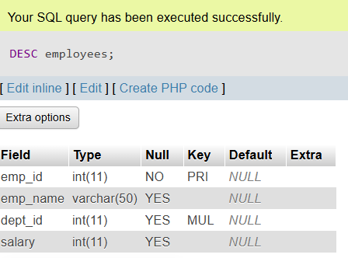

Step 2: Fix the query based on real column names

Example 1 (if columns are like this):
employees table
- emp_id
- emp_name
- salary
- dept_id
departments table
- dept_id
- dept_name
Then use:
CREATE VIEW employee_department_view AS
SELECT
e.emp_id,
e.emp_name,
e.salary,
d.dept_name
FROM
employees e
JOIN
departments d
ON
e.dept_id = d.dept_id;
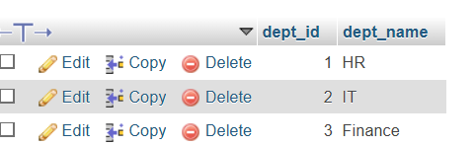

- SQL Triggers
Theory Questions:
1. What is a trigger in SQL? Describe its types and when they are used.
Trigger in SQL (Simple):
A trigger is a special SQL procedure that runs automatically when an event (like INSERT, UPDATE, DELETE) occurs on a table.

🔹 Types of Triggers:
- BEFORE Trigger
→ Runs before the operation
→ Used to validate or check data
- AFTER Trigger
→ Runs after the operation
→ Used to log changes or update related data
- INSTEAD OF Trigger
→ Runs instead of the operation
→ Used mostly with views

🔹 When they are used:
- To automatically enforce rules
- To maintain data consistency
- To track or log changes
2. Explain the difference between INSERT, UPDATE, and DELETE triggers.
Difference between INSERT, UPDATE, and DELETE Triggers (Simple):
Trigger Type | When it Executes | Purpose
INSERT Trigger | When new data is added | To check or act on new records
UPDATE Trigger | When existing data is modified | To track or validate changes
DELETE Trigger | When data is removed | To log or handle deleted records

- Introduction to PL/SQL
Theory Questions:
1. What is PL/SQL, and how does it extend SQL's capabilities?
PL/SQL (Simple):
PL/SQL (Procedural Language/SQL) is an extension of SQL used in databases like Oracle.
👉 How it extends SQL: 2. List and explain the benefits of using PL/SQL.
- Adds programming features like loops and conditions (IF, LOOP)
- Allows writing blocks of code (procedures, functions)
- Helps handle errors (exception handling)
- Supports complex operations in one program
2. List and explain the benefits of using PL/SQL.
Benefits of PL/SQL (Simple):
- Better Performance
→ Executes multiple SQL statements in one block
- Reusability
→ Code can be reused using procedures and functions
- Error Handling
→ Handles errors using exception handling
- Security
→ Restricts direct access to data
- Supports Programming Logic
→ Allows use of loops, conditions (IF, LOOP)
- PL/SQL Control Structures
Theory Questions:
1. What are control structures in PL/SQL? Explain the IF-THEN and LOOP control structures.
Control Structures in PL/SQL (Simple):
Control structures are used to control the flow of execution in a PL/SQL program.

🔹 IF-THEN
- Used to make decisions
- Executes code only if a condition is true
IF condition THEN
-- statements
END IF;

🔹 LOOP
- Used to repeat a block of code
- Runs until a condition is met
LOOP
-- statements
EXIT WHEN condition;
END LOOP;
2. How do control structures in PL/SQL help in writing complex queries?
Role of Control Structures in PL/SQL (Simple):
Control structures help to handle complex logic in SQL programs.
👉 How they help:
- IF-THEN → Make decisions based on conditions
- LOOP → Repeat tasks multiple times
- Better control → Execute steps in a proper order
- Handle complex tasks → Combine multiple operations in one block
- SQL Cursors
Theory Questions:
1. What is a cursor in PL/SQL? Explain the difference between implicit and explicit cursors.
Cursor in PL/SQL (Simple):
A cursor is a pointer used to fetch and process data row by row from a query result.

🔹 Types of Cursors:
Feature | Implicit Cursor | Explicit Cursor
Definition | Automatically created by SQL | Created manually by user
Usage | For simple queries | For complex queries
Control | Less control | More control
Example | SELECT, INSERT (auto handled) | Defined using DECLARE, OPEN, FETCH, CLOSE

2. When would you use an explicit cursor over an implicit one?
When to Use an Explicit Cursor (Simple):
Use an explicit cursor when you need more control over data processing.
👉 You use it when:
- You want to process rows one by one
- You need to apply complex logic on each row
- You want to control opening, fetching, and closing of data
- When a query returns multiple rows and needs detailed handling

- Rollback and Commit Savepoint
Theory Questions:
1. Explain the concept of SAVEPOINT in transaction management. How do ROLLBACK and COMMIT interact with savepoints?

What is SAVEPOINT?
A SAVEPOINT is like a checkpoint inside a transaction.
👉 It lets you go back to a certain point instead of cancelling everything.

🔹 Example (Easy)
BEGIN;
INSERT INTO student VALUES (1, 'Raj');
SAVEPOINT A;
INSERT INTO student VALUES (2, 'Amit');
SAVEPOINT B;
INSERT INTO student VALUES (3, 'Neha');

🔹 ROLLBACK with SAVEPOINT
ROLLBACK TO A;
👉 This will:
- Remove Amit and Neha
- Keep Raj
✔ Only changes after SAVEPOINT A are undone

🔹 COMMIT
COMMIT;
👉 This will:
- Save all data permanently
- Delete all savepoints
❌ After COMMIT, you cannot rollback

🔹 Very Simple Idea
- SAVEPOINT → mark a point
- ROLLBACK TO → go back to that point
- COMMIT → save everything forever

🎯 Easy Example (Real Life)
Think of writing a document:
- SAVEPOINT = saving a draft
- ROLLBACK = go back to old draft
- COMMIT = final submit (no changes allowed)
2. When is it useful to use savepoints in a database transaction?

✅ 1. In Large Transactions
When a transaction has many steps:
- You can go back to a specific step
- No need to cancel the whole work
👉 Example: Adding multiple records in a database

✅ 2. When Errors May Occur
If some part of the transaction might fail:
- Use SAVEPOINT before that step
- Rollback only the failed part

✅ 3. Partial Undo Needed
When you want to:
- Keep some changes
- Remove only unwanted changes

✅ 4. Complex Operations
In operations like:
- Banking transactions
- Order processing systems
👉 SAVEPOINT helps manage each step safely

